YEAR 1 - A Secret Garden
Art National curriculum Objectives:  - to use a range of materials creatively to design and make products  - to use drawing, painting and sculpture to develop and share their ideas, experiences and imagination  - to develop a wide range of art and design techniques in using colour, pattern, texture, line, shape, form and space  - about the work of a range of artists, craft makers and designers, describing the differences and similarities between different practices and disciplines, and making links to their own work. |  | Previous learning:  Building on from EYFS  During the time in our early Years setting, we have provided the children with a range of materials to use to express themselves and to think about and discuss what they want to make through our continuous provision. They have been able to:  - Draw with increasing complexity and detail  - Explore colour and colour mixing  - Explore different materials freely, to develop their ideas about how to use them and what to make.  Vocabulary encountered in Nursery: cut, stick, join, glue, cellotape, tape, blue-tack, glue stick, paper, art, artists, craft, making, draw, copy, up, down, side to side, round and round, pencil, paint, crayon, pen, chalk.  Vocabulary encountered in Reception: colour, colour mixing, light, dark, lighter, darker, how, what, why, where, carefully, rough, smooth, spiky, soft, hard, sticky, line, circle.  Current Year During art in this current year the children have worked on ‘traditional tales’ topic and learnt about illustrators- looking at book covers and using mixed media to create own book cover. They Draw and create models of houses to build a replica of Pudding Lane and have created a detailed drawing of a dinosaur that they have created in the ‘Dinosaur discoveries’ topic.
Key Learning  - Know about Georgia O’Keefe and explore her artwork,  - talk about how Georgia O’Keefe’s work has been created, (colours, media used etc)  - Evaluate some of Georgia O’Keefe’s artwork and discuss their favourite piece using language related to art.  - Create their own piece of art using Georgia O’Keefe as inspiration.  - Techniques used to draw from observation:  - experiment with different pencil grades in your sketchbook.  - experiment drawing different textures with different pencils in your sketchbook.  - Experiment with using charcoal for hard and soft lines.  - Use photography and view finders to design their own piece of artwork.  - Techniques used to create clay sculptures – rolling, pressing, wetting, pinching, smoothing, etc and add patterns and textures. |  |  | Skills  - exploring their ideas and recording their experiences  - produce creative work using pencil, paint and clay  - develop proficiency in drawing, painting, sculpture and other art, craft and design techniques  - mix different colours  - mix paint for shades and tints.  - evaluate and analyse creative works using the language of art, craft and design.  - Draw texture with pencil  - Add shading with a pencil  - Draw with charcoal  - Manipulate and sculpt with clay
Key people  Georgia O’Keefe | Key Vocabulary:  Media, materials, drawing, painting, design techniques, Sculpting, rolling, pressing, wetting, pinching, smoothing, colour, pattern, texture, line, shape, form, space, artists, tone, texture, hatching, cross hatching, stippling, shading, smudging, space, background
Key Knowledge that children should know and remember by the end of the topic:
Who was Georgia O’Keefe? Born in 1887, Georgia O’Keefe was an American artist who painted nature in a way that showed how it made her feel.
What was she famous for? She is best known for her paintings of flowers and desert landscapes.
How did Georgia O’Keefe’s create her work? (colours, media used etc) She used a variety of media: pastel, charcoal, watercolour and oil paint.
What is a sculpture? Art in 3D!! Sculptures can be made by carving, modelling or placing materials together. They can be made out of stone, clay, wood or any other materials the artist wants to use!
Children can talk about a piece of Georgia O’Keefe’s artwork and discuss using language related to art.
Children can talk ways to create shading- how do we make a colour darker? Lighter?

Cross Curricular Links
English Key Text – A Secret Garden – use the illustrations within the secret garden as inspiration for a large Secret Garden display which all children will add to and complete as a whole class project.
Science – Plants – Revisiting prior learning
ICT – Photography of flowers
Resource list: Modelling clay, clay tools, playdough, real flowers, drawing pencils of different grades, good quality paper/card (for water colours and other media), charcoal, coloured chalks, pastels, clear varnish, brushes (fine), brightly coloured card and paper, black sharpie pens, black wax crayons, magnifying glasses,
Georgia O'Keeffe (Revised Edition) (Getting to Know the World's Greatest Artists) Paperback https://www.amazon.co.uk/Georgia-Revised-Getting-Greatest Artists/dp/0531212912/ref=sr_1_4?dchild=1&keywords=Georgia+O%27Keeffe&qid=1620581960&sr=8-4
Easy Art for Kids - Clay Flower - https://www.youtube.com/watch?v=2FLqzFAplk0
https://www.okeeffemuseum.org/creative-activities/
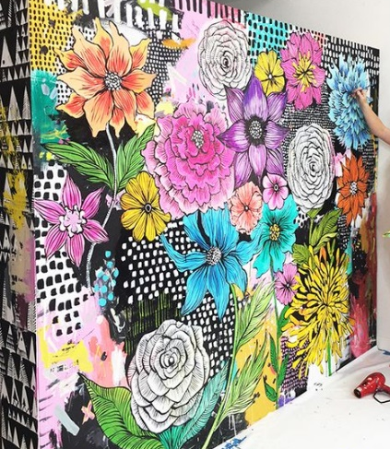
Week 1 – Introduce Georgia O’Keefe/ water colours

Week 2 – Explore alternative media/learn and develop techniques for drawing and painting/observational flower drawings. (Could each child create a flower to become part of a larger display in the dining room or hall?

Week 3 – Go for a walk and take photographs of flowers (allotment/Elvaston Castle/Garden centre?) Use photographs of flowers and viewfinders for children to begin their own artwork piece

Week 4 – Practise sculpting using playdough, teaching different techniques including using clay tools. Make clay sculpture flowers

Week 5 – Paint and glaze clay flowers.

