
Acorn Class

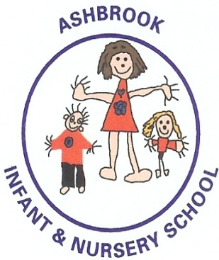
Nursery Brochure

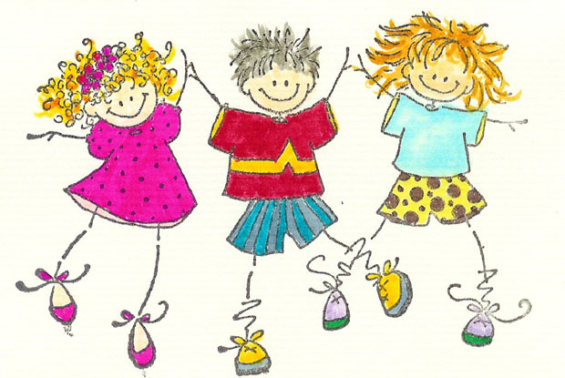

Welcome


We firmly believe that children develop best in a happy, secure, consistent environment and therefore, that it is by us developing a good relationship with you and working together that we can ensure the best care and education for your child.

We would like to take this opportunity to welcome you and your child to our Nursery. We are really looking forward to meeting you and getting to know you all, whether you are old friends returning or new friends we have yet to meet.


We want to take this opportunity to invite you to be as involved with the nursery as possible. We have an open door policy and want you to feel that you can approach any of us at any time with any questions, concerns or worries you might have, however trivial they may seem.

It is with this aim in mind that we have produced this booklet to give you a flavour of who we are and what we do and to suggest ways in which you can help and support your child.

Contents

Admissions
- Places 4
- Visits and Induction 4
Our Ethos 5
Our Staff 6
- Keyworkers 7
- Our Governors 7
Inside Nursery 8 - 9
Outside Nursery 9
Weekly Routine 10
Everyone a Learner 11
Curriculum 12 - 14
Behaviour 15
Special Needs
- Equal Opportunities 16
- Special Educational Need 16
- Child Protection 16

Quick Reference
- Activity Money 17
- Snack 17
- Clothing 18
- First Aid 19
- Headlice 19
- Illness 19
- Medicines 19
- Data Protection 20
- Jewellery 20
- Photographs 20
- Birthdays 20
- Toys 20
Contact Details 21

Admissions

Places
At Ashbrook Nursery we offer flexible sessions over 5 days (up to 30 hours) from 8.45am. Children are admitted to our nursery in the term that follows their 3rd birthday. E.G if they are 3 in July, they start in September, if they are 3 in November, they start in January.

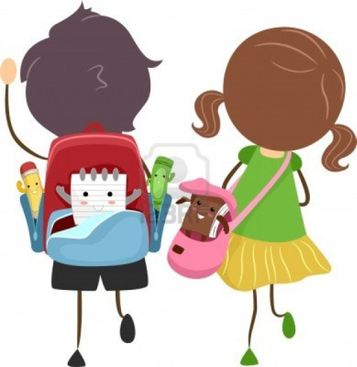
Visits and Induction
Once your details are on our system, we will get in touch with you the term before your child is due to start. You will be invited to a series of visits where you can stay with your child and explore the nursery environment. After these visits our nursery team will make individual appointments before your child starts, this will help us get to know your child and you better.



You can apply for nursery by registering your child at the school office any time following their second birthday. Please also feel free to call the office to make an appointment to look around. We would love to see you.

Our Ethos

We Care

At Ashbrook Nursery we encourage a caring, sharing, supportive environment where everyone can feel accepted, valued and loved.

We Learn

At Ashbrook Nursery we aim to provide an environment which encourages curiosity, excitement and enthusiasm to explore, discover and learn.

We have fun
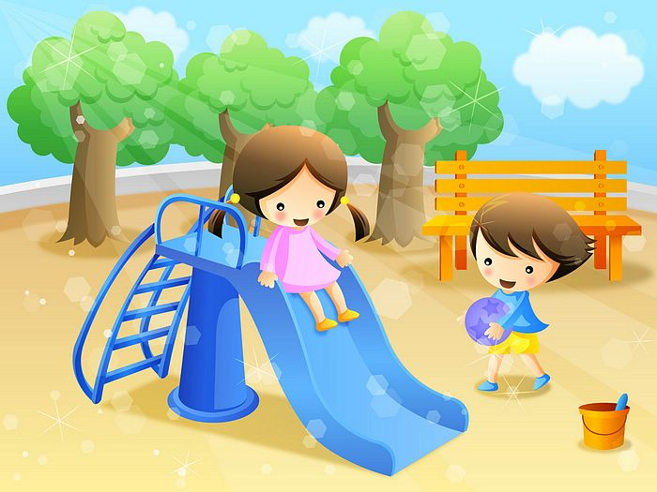
But most of all we want learning to be Free, Uninhibited and Natural, otherwise known as FUN!

‘Children settle well in the nursery and early years. Adults quickly establish routines to ensure that classrooms are calm spaces.’ OFSTED 2022

Our Staff

We are fortunate that our Nursery is staffed by highly qualified, enthusiastic and hard working staff. They are:
- Our teachers are Mrs Floyd and Mrs Purdon, they share the teaching across the week
- Our Teaching Assistants are Mrs Smullen and Mrs Cross, they share the teaching across each day


We also, at times have students working in the nursery under the direction of the nursery teacher. We respect the contribution which they make and view them as members of staff.

The nursery staff work very closely with other staff within the school. We are particularly supported by:
Mrs Helen Roebuck – Headteacher
Mr Nathaniel Coxon and Mrs Jenny Wallace- our office team



Please feel free to contact or approach either Mrs Floyd, Mrs Purdon, Mrs Smullen, Mrs Cross, Mr Coxon, Mrs Wallace or Mrs Roebuck at any time, as they are more than happy to speak to you or help you.

Our Staff

Key Workers
All children are taken in to small groups and work with a qualified teacher and teaching assistant. Each group are taught phonics, number and have story time. Assessments are carried out during these group sessions and the groups are changed on a half termly basis to ensure that all adults get to know and work with all of the children. This helps to utilise the skills of all the adults in the nursery to benefit all of the children.

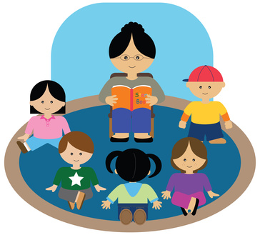
Our Governors
Along with the headteacher, the governors are responsible for the budget, staff and school buildings. They meet both as a whole, and in small groups with a specific focus, all through the school year. This is led by:
- Miss Margaret Smith – Chair of Governors

Vacancies for parent representatives often arise throughout the year so if you feel you would be interested please contact Mrs Roebuck who will be more than happy to give you some more information.



Inside Nursery

The Nursery has several indoor zones and the seven areas of learning in the Early Years are catered for across these zones.
The wet end (hard floor that is easy to clean!) hosts the art areas, the writing area, the sand and the malleable area.

The carpeted end hosts the home areas, the ICT area, the fine motor area, the book corner, small world, construction and the snack area.
The teaching area (The Base) is used for group sessions but also hosts our reading area and the interactive whiteboard.
The quiet, cosy corner is situated at the end of the nursery and is a place for children to choose to go to chat with friends or be by themselves.

The entrance hall is sometimes used as another teaching area. It is also used for lunchtime.

Outside Nursery

The Nursery also has its own outdoor area. This consists of a vegetable bed, wildlife area, flower beds, paved area, grassed hill, and soft surfaces area.
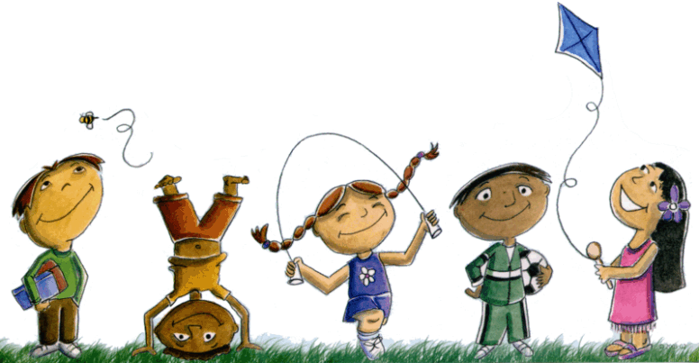
This area has hanging bars, a building site, a mark making and reading area, a musical area, a natural material area, a den and a mud kitchen permanently set up. We also provide a variety of activities which cover all areas of the curriculum on a weekly basis.
We also have access, via a gate, to the school playground where there is ample space for cars, bikes and scooters.

The children have freeflow access to the activities available in this area on a daily basis.



Weekly Routine

The nursery day commences at 8.45am or 12pm, the children are free to choose their own learning until the register is taken and group time begins. The nursery sessions are 8.45am- 11.45am (morning), 12pm-3pm (afternoon) or 8.45am-3pm (full day).
We ask that you bring your child into the nursery garden at the start of their session and come through the door at the playground end of the building with your child.

The children have freeflow play across both the indoor and outdoor environments, which is child initiated.
Once all of the parents have left we close the door and gather together to greet each other on the carpet. After this the children go into groups to do a listening activity or number work.

Friday is our special day when we concentrate on developing physical skills. The children will take part in PE in the hall or outside. We ask that you bring them dressed appropriately in jogging bottoms and trainers as we do use a variety of apparatus.


Everyone a learner

We firmly believe that all of our children can try and succeed and so have a ‘you can!’ ethos in our nursery.

The revised EYFS framework sets out guidelines for the skills that children need to develop in order to be able to learn. These are called characteristics of effective learning.

Playing and Exploring (engagement) -
- Finding out and exploring
-Playing with what they know
-Being willing to have a go

Active Learning (motivation)
- Being involved and concentrating
- Keeping on trying
- Enjoying achieving what they set out to do.

Characteristics of effective learning.

Creating and Thinking Critically (thinking)
- Having their own ideas
- Making links
- Choosing ways to do things.


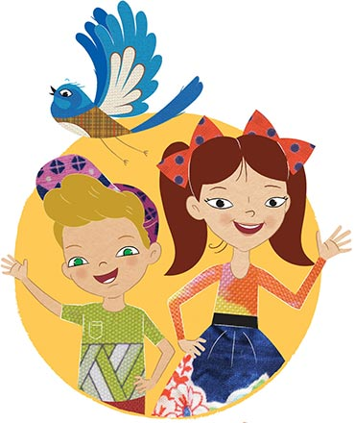

Curriculum

The nursery and reception classes are referred to as the Foundation Stage. During the Foundation Stage, children work to the Early Years Foundation Stage Curriculum (EYFS). The EYFS seeks to see the child as a whole and recognises the need for them develop skills and knowledge in seven main areas.
The three prime areas of learning are very important as they underpin everything else that your child is going to learn.

Physical Development
- Gross Motor Skills
- Fine Motor Skills

Communication and Language
- Listening, attention and understanding
- Speaking

Personal, Social and Emotional Development
- Self-regulation
- Managing self
- Building relationships



Curriculum

The specific areas of learning build on the prime areas.
Literacy
Comprehension
Word Reading
Writing

Understanding the world
Past and Present
- People, culture and communities
- The natural world
- Technology

Mathematics
- Number
- Numerical Patterns

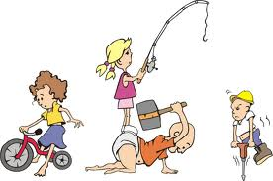
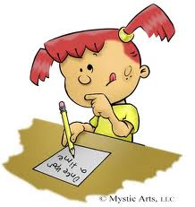
Expressive arts and design
- Creating with materials
- Being imaginative and expressive

At Ashbrook Nursery we feel that it is vitally important for your children to develop in all of these areas and so we make sure that they are all available, in some form, on a daily basis.

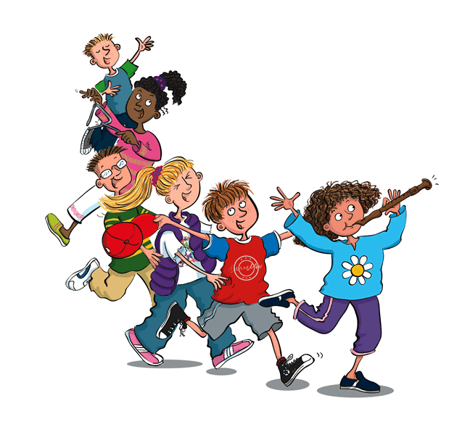
Curriculum

We firmly believe that children learn best through play and this occurs best through a well thought out, accessible environment where adults sensitively and purposefully interact with children

We also believe that each child is an individual with different strengths and needs and that each of their learning journeys will be as individual as the children themselves.

We fully understand that children of this age will go home and be reluctant or unable to say what they have done at nursery but we have a book that you can come and look at to see what they have been learning.



Behaviour

At Ashbrook Nursery we believe that everyone should demonstrate respect for each other and the facilities and resources provided.

We are aware, however, that we are dealing with very young children for whom this can be extremely challenging. As young children can be egocentric (all about me), it is often difficult for them to be aware of others or understand the needs of others. We also appreciate that not all our children will have experienced a childcare setting before the age of 3 and that nursery may be their first experience mixing with larger groups of children, away from their adults and their home.

We are sensitive to children’s individual experiences and spend much of our first term with the children making the expectations of the setting clear. We work with the children in circle times and general play situations to help them to get to know and care about each other.

Across the whole school:
We are KIND (we do not hurt each other physically or verbally)
We LISTEN (to adults and our friends, we may disagree with our friends but we are polite about it)
We WORK and PLAY HARD (we do as we are asked by the adults when we are asked to do it)
We WORK and PLAY TOGETHER (we work or play with our friends calmly and politely)
We STAY SAFE (we make sure that we do as the adults ask and we tell an adult if anything or anyone makes us feel unsafe)


Special Needs

Special Educational Needs
At nursery we aim to provide an environment where every child can reach their potential. We constantly monitor all children’s progress and any concerns are discussed with parents or carers. Mrs Roebuck is our Special Needs Coordinator and may become involved with your child if you think it necessary.
From time to time advice may be sought from professional agencies such as the Educational Psychology Service, Speech and Language Service, Occupational Therapy etc. They will help to set up individual targets and programmes for the children and families.
Equal Opportunities
Ashbrook Infant and Nursery School seeks to ensure that all children receive equal treatment regardless of sex, disability, race, colour, ethnic or national origin in line with Derbyshire
County Council’s Equal Opportunities Policy.

Policy.
Safeguarding
We need to make you aware that we are required to take any reasonable action to ensure the safety of our pupils. In cases where we have reason to be concerned that a child is subject to ill treatment, neglect or any other form of abuse, we are obliged to follow the Derbyshire Child Protection Procedures and inform Social Care of our concerns. Wherever possible, a designated safeguarding lead will discuss this with you first.

‘Disabled pupils and those who have special educational needs make good progress because teachers and teaching assistants know the children extremely well and ensure that support is carefully matched to their needs.’ OFSTED 2013.
‘Disabled pupils and those who have special educational needs make good progress because teachers and teaching assistants know the children extremely well and ensure that support is carefully matched to their needs.’ OFSTED 2013.
‘Disabled pupils and those who have special educational needs make good progress because teachers and teaching assistants know the children extremely well and ensure that support is carefully matched to their needs.’ OFSTED 2013.
‘Disabled pupils and those who have special educational needs make good progress because teachers and teaching assistants know the children extremely well and ensure that support is carefully matched to their needs.’ OFSTED 2013.
‘Disabled pupils and those who have special educational needs make good progress because teachers and teaching assistants know the children extremely well and ensure that support is carefully matched to their needs.’ OFSTED 2013.
‘Disabled pupils and those who have special educational needs make good progress because teachers and teaching assistants know the children extremely well and ensure that support is carefully matched to their needs.’ OFSTED 2013.
‘Disabled pupils and those who have special educational needs make good progress because teachers and teaching assistants know the children extremely well and ensure that support is carefully matched to their needs.’ OFSTED 2013.
‘Disabled pupils and those who have special educational needs make good progress because teachers and teaching assistants know the children extremely well and ensure that support is carefully matched to their needs.’ OFSTED 2013.
‘Disabled pupils and those who have special educational needs make good progress because teachers and teaching assistants know the children extremely well and ensure that support is carefully matched to their needs.’ OFSTED 2013.
‘Disabled pupils and those who have special educational needs make good progress because teachers and teaching assistants know the children extremely well and ensure that support is carefully matched to their needs.’ OFSTED 2013.
Quick reference


Activity Money
With the aim of providing the best possible learning experiences we really like to provide our children with extra activities such as cooking, sewing and gardening. You will also find that we try to provide extra activities from outside of school at points during the year. In order to fund these we do ask if you could possibly make a contribution of 50p a week.
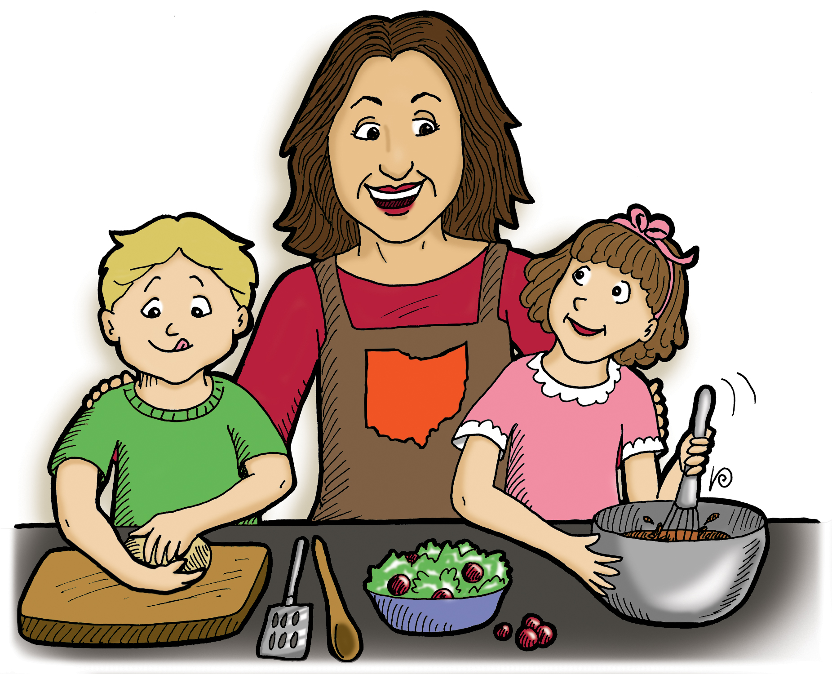
Lunch Times
If your child is staying for lunch they will either need a packed lunch or we also offer the children an option of a hot meal cooked by Aspens at the cost of £2.56 a day. Your child will have the option to swap and change between packed lunches and the daily hot meal.
Please remember we are a nut free school
The menu is available on our school website at https://www.ashbrookinfantandnursery.co.uk/lunch-menus/

Snack
The children are given access to snack each day. We try to develop their independence by encouraging them to help themselves during the course of the morning. We provide a piece of fruit and a carton of milk or a glass of water. We have found that it is a long time for some of the children to go between breakfast and lunch and so we now also provide another snack such as toast, tea cakes, crumpets, crackers etc. We do ask that you make a donation of 50p a week to cover the cost of the extra snack.

Quick reference

We like to provide the children with a wide range of experiences to explore the world with all of their senses so please don’t send them in their best clothes as, even though aprons are always provided, they will get dirty!
Clothing
As we work with you to develop independence in your child, it would be really useful if they can come in clothes which they can manage easily e.g. sleeves that roll up easily, pull on trousers / leggings – no zips, buttons, laces or buckles please.
We would also like the children to wear a red or royal blue jumper or cardigan.
As the children do a lot of running, jumping and climbing at nursery we do ask that they wear sensible footwear so that they can safely engage in all the activities on offer. We also ask that you provide a pair of wellies that can be left in nursery for playing out on wet days. Please can you ensure that your children can change their shoes by themselves, i.e. Velcro shoes (no laces).
We like to ensure that the children have the opportunity to play both inside and outside whenever possible so please could you make sure that they have appropriate clothing e.g. warm coats, hats, scarves and gloves in the winter and sun hats, sun cream, covered shoulders etc.in the summer. Unfortunately, the weather in this country can be very unreliable so please could you make sure that they are covered for any eventuality.

Please provide a pair of slippers that can be kept in nursery.

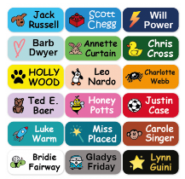
Please remember to write your child’s name on all clothing.

Quick reference


First Aid
As small children often have little accidents when they are moving around and exploring, we always have a paediatric first aider on hand to care for them. We will either inform you of accidents when you pick your child up or, in the case of bumped heads or more serious injuries we may phone you to collect your child.

Please can you ensure that we always have the correct contact details in case we need to contact you quickly.

Head lice
Please could you check your child’s hair regularly and if you find any headlice please treat their hair before they return to nursery.
Illness
When small children first come into contact with large groups of children they often pick up lots of bugs and viruses. Please think carefully about whether your child is well enough to come to nursery. If your child has a stomach upset, please keep them at home for 48 hours after their last bout of sickness or diarrhoea.

Medicines
If your child is in nursery for only three hours the chances are that they will not need any medicines during the session. However if your child is in nursery all day, staff will follow Derbyshire County Council guidelines when administrating medicine.
If your child uses an inhaler please ensure that it is clearly labelled with the child’s name and dosage instructions.

If your child has any other medical conditions please speak to staff so that we can ensure that they are cared for appropriately.

Quick reference

Data Protection Act
It is necessary for us to hold basic information about pupils on our administration computer to assist with the efficient organisation of the school.
Security measures are taken to ensure that the information is kept confidential and is only available to authorised staff.
Toys
Toys are not allowed in nursery. However, if your child is finding the transition between home and nursery a challenge, please talk to staff who will support your child in using a special soft toy / comforter from home to help them in at the start of the session.
Photographs on Dojo
We do take photographs and videos of the children. Please could you inform Nursery staff if you have special requests about your child being photographed or any concerns as to how they are used.
Birthdays
We always have a special celebration time when it is someone’s birthday but we prefer you not to bring in sweets or cakes as we are a healthy school.

Jewellery
Please do not send your child to school in jewellery as not only can these get lost or broken but they can also be a safety hazard. If your child has pierced ears please ensure that they only wear small studs.
Contact Details

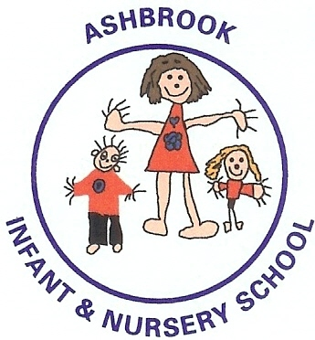
Ashbrook Infant and Nursery School
Borrowash
Derby
DE72 3HF

Telephone : 01332 662695

Email: info@ashbrook-inf.derbyshire.sch.uk

Please feel free to visit our website at:
www.ashbrookinfantandnursery.co.uk

