
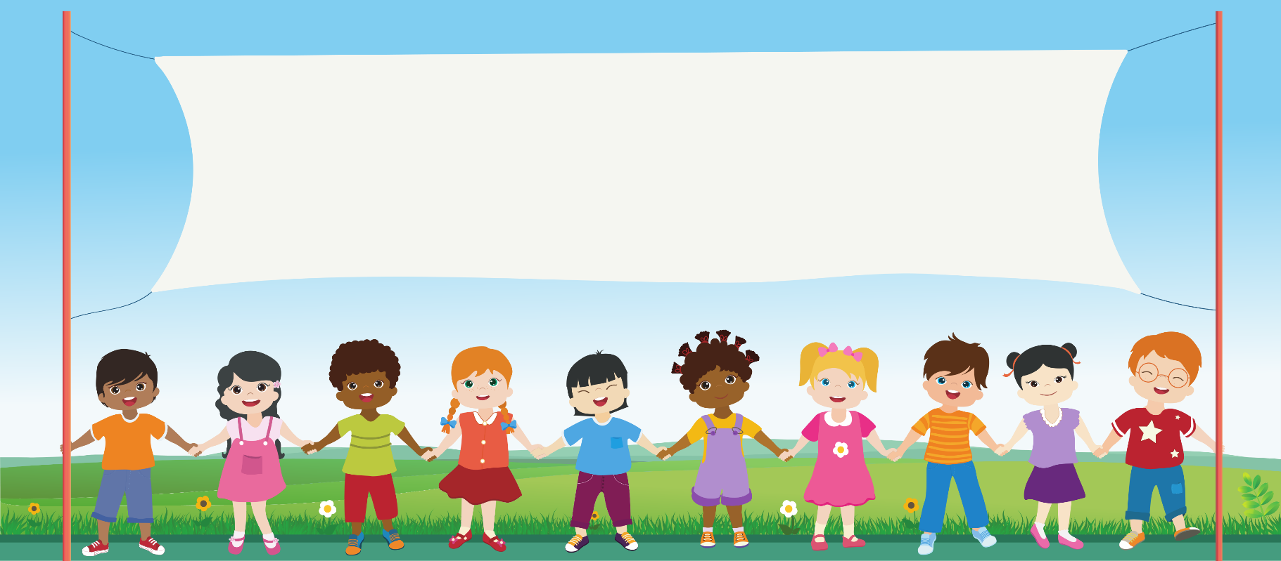
Ashbrook Infant and Nursery School
Pupil Privacy Notice


What is a Pupil Privacy Notice?
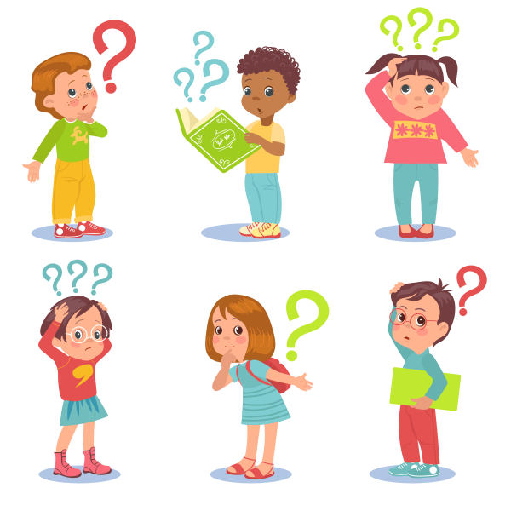
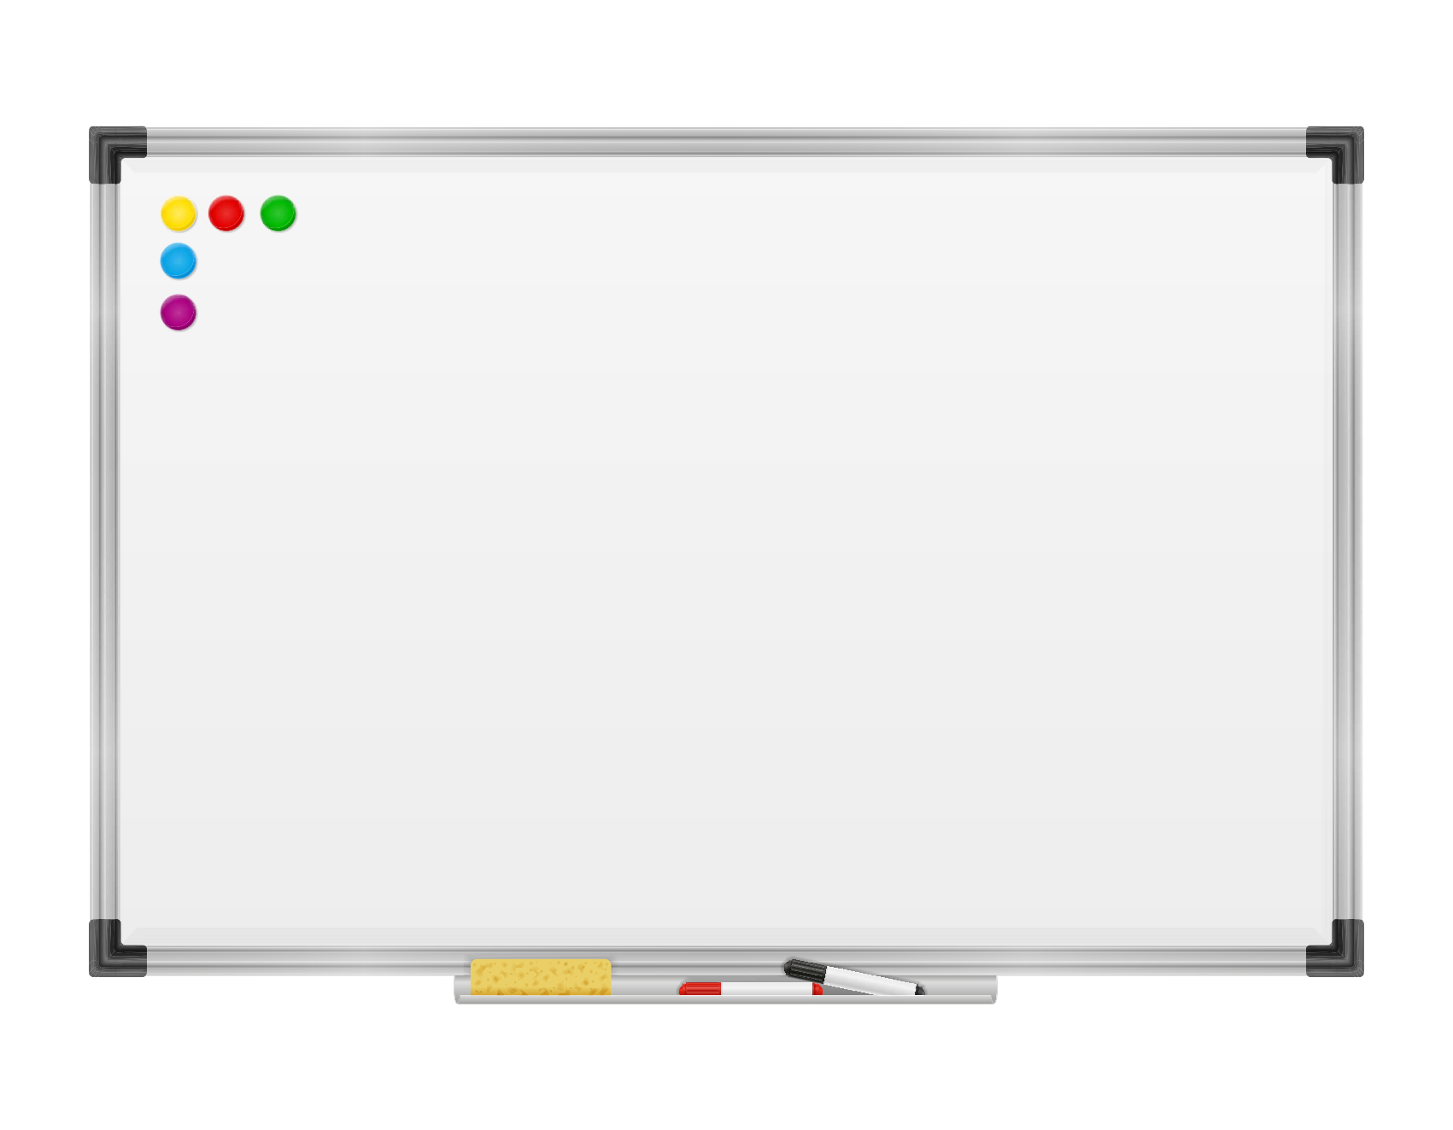
A Pupil Privacy Notice tells you the information school has about you, what we do with it and who we share it with. This information is called ‘personal data’ – in school we often call it ‘data’.
What ‘data’ does school
have about me?

- Your name, your birthday, where you live, who you live with.
- Days you come into school and when you are sick or not able to come to school for a reason.
- The class you are in.
- How you are learning and marks from tests you do.
- How you behave at school.
- If you have school meals.
- Your doctor’s name and any medicines you need to have, or food that makes you ill.
- Photographs of you so we know what you look like.
- Any letters or other information we receive or send home.
- Any other information we need to know to keep you safe.

That’s quite a long list, so by the time you leave our school we will have collected a lot of data about you!
Some of this data is called ‘special category data’. This means it tells us a bit more private information about you, like what extra needs you have, any medical information (like allergies, food, medicine you need to take). This helps us take care of you.
How do we get this ‘data’?

We get this data when you join our school and when teachers help you learn. Other people like your doctor, government departments or other schools you have been to, might also give us information about you.
Why does school need this ‘data’ about me?
We have your data to help you learn and to make sure you understand your lessons. It also helps us keep you safe. Sometimes we need this information because the law says so, or so we can talk to the people who look after you at home (for example if you are sick we can contact them, or to let them know how well you are doing) and sometimes we need to ask the people who look after you at home for their permission to use your data (for example to use your photographs on our website or in school newsletters).
Who will see and use my ‘data’?
We share your data with:
- Your parents or carers
- The people who make and serve your school dinners, so they know if any foods make you ill
- Your teachers and the school office staff so they can help you
- Governors, the local council, or the Department for Education, to make sure we are doing our job properly
- Doctors or nurses, if you are unwell or need help
- Electronic systems in school, to help us run the school well and for you to use online learning tools.
How long do you keep my ‘data’?
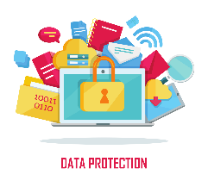
We keep all your data safe in school only for as long as we need it. When you leave school, we give your data to your new school. When we don’t need your data anymore, we destroy it safely. Some data we need to keep for longer, but we look after it carefully.
We do not give your information to anyone who should not have it.
Can I ask you about the ‘data’ you keep on me?
We have to tell you what personal data we have and what we do with it.
You (or your parents or carers) can ask to see any of the data we keep about you.
If you want to see this information or to find out more about what we have talked about in this Privacy Notice, or if you have any questions about the data we hold about you, please ask your teacher or the school office for help. We also have a ‘Data Protection Officer’ (DPO) who can help explain what school is doing with your data and ensure it is right.
You can say that you don’t want us to use your data in certain ways, but if we use it to keep you safe or help you learn you can’t say no.

People to speak to about your ‘data’
Our DPO is Education Data Hub – you or your family can get in touch with them by email dpforschools@derbyshire.gov.uk or phone on 01629 532888.
If the DPO can’t help you, you can ask an adult to contact the ICO (Information Commissioner’s Office) – the ICO is an important organisation that makes sure your data is safe.
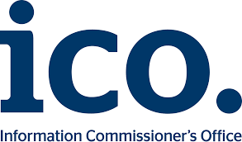
The ICO can be contacted by calling 0303 1231113 or by writing to them at the Information Commissioner’s Office, Wycliffe House, Water Lane, Wilmslow, Cheshire, SK9 5AF.

We will always look after your data to make sure it is safe in school

